**InsightStream: Navigate the News Landscape**

**Ideation Phase**

**Brainstorm & Idea Prioritization**

|  |  |
| --- | --- |
| Date | 31 January 2025 |
| Team ID | SWTID1741176034150337 |
| Project Name | NEWS APP |
| Maximum Marks | 4 Marks |
| TEAM MEMBERS | RINOSHA FATHIMA.S-[**rinoshafathima786@gmail.com**](mailto:rinoshafathima786@gmail.com) |
|  | JAYASHREE.R- [jayashreeanitha05@gmail.com](mailto:jayashreeanitha05@gmail.com) |
|  | MONIKA.S- [monikasankar2022@gmail.com](mailto:%20%20monikasankar2022@gmail.com) |
|  | RESHMA.S - reshmas24ug@gmail.com |
|  | KALAIVANI.M -kalaivanimohan20@gmail.com |

**Brainstorm & Idea Prioritization Template:**

Brainstorming provides a free and open environment that encourages everyone within a team to participate in the creative thinking process that leads to problem solving. Prioritizing volume over value, out-of-the-box ideas are welcome and built upon, and all participants are encouraged to collaborate, helping each other develop a rich amount of creative solutions.

Use this template in your own brainstorming sessions so your team can unleash their imagination and start shaping concepts even if you're not sitting in the same room.

Reference: <https://www.mural.co/templates/brainstorm-and-idea-prioritization>

**Step-1: Team Gathering, Collaboration and Select the Problem Statement**

**Step-2: Brainstorm, Idea Listing and Grouping**

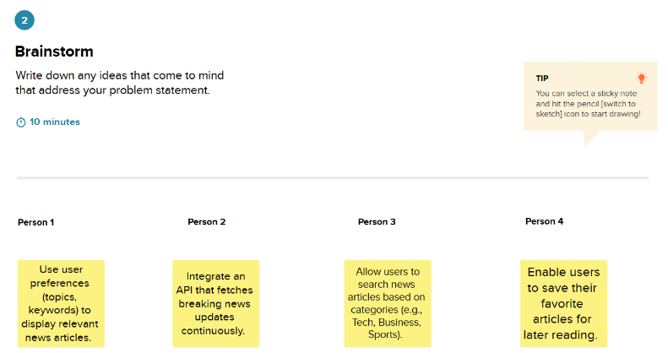

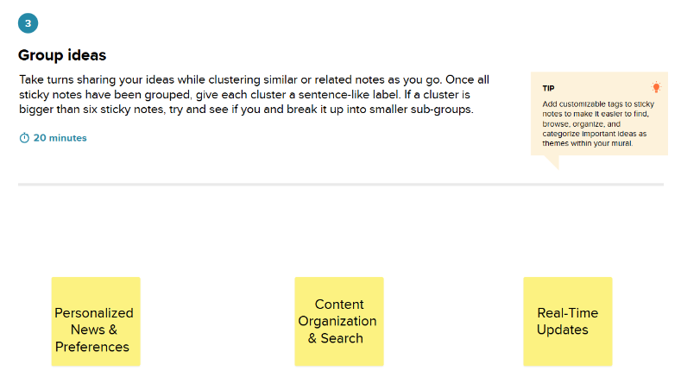

**Step-3: Idea Prioritization**

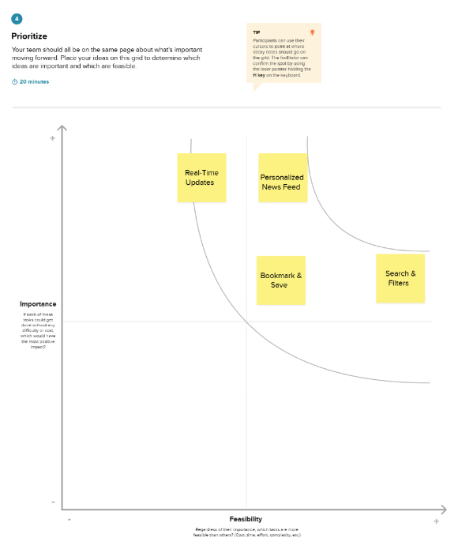

**InsightStream: Navigate the News Landscape**

**Ideation Phase**

**Define the Problem Statements**

|  |  |
| --- | --- |
| Date | 5 March 2025 |
| Team ID | SWTID1741176034150337 |
| Project Name | NEWS APP |
| Maximum Marks | 2 Marks |
| TEAM MEMBERS | RINOSHA FATHIMA.S-[**rinoshafathima786@gmail.com**](mailto:rinoshafathima786@gmail.com) |
|  | JAYASHREE.R- [jayashreeanitha05@gmail.com](mailto:jayashreeanitha05@gmail.com) |
|  | MONIKA.S- [monikasankar2022@gmail.com](mailto:%20%20monikasankar2022@gmail.com) |

**Customer Problem Statement Template:**

Create a problem statement to understand your customer's point of view. The Customer Problem Statement template helps you focus on what matters to create experiences people will love.

A well-articulated customer problem statement allows you and your team to find the ideal solution for the challenges your customers face. Throughout the process, you’ll also be able to empathize with your customers, which helps you better understand how they perceive your product or service.

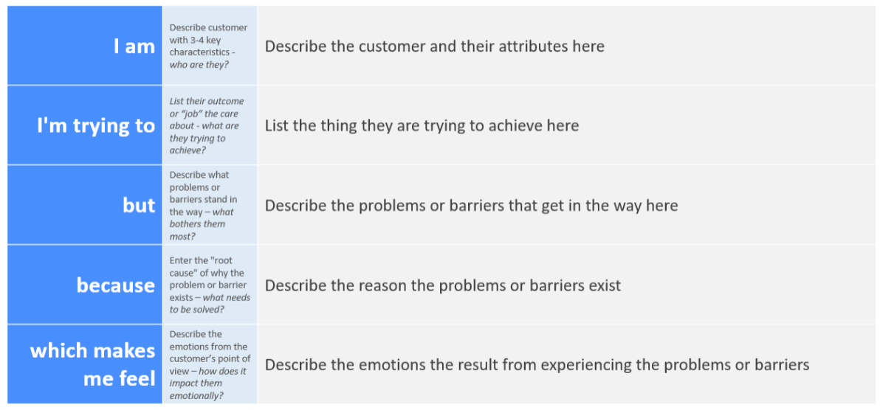

Reference: <https://miro.com/templates/customer-problem-statement/>

**Example:**

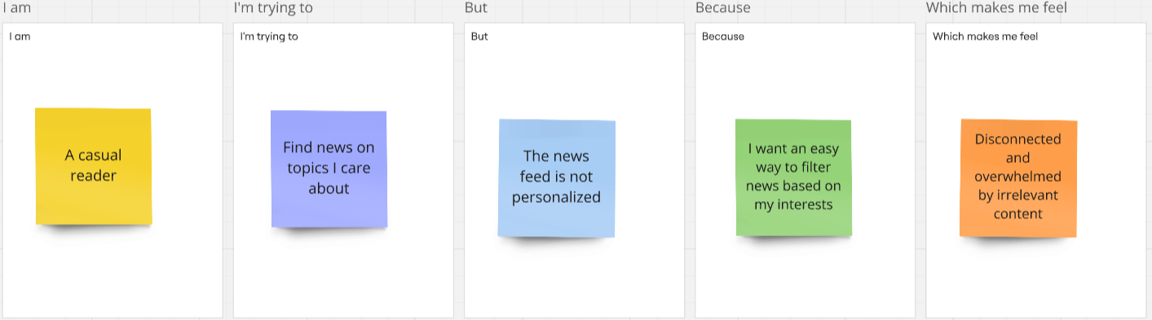

|  |  |  |  |  |  |
| --- | --- | --- | --- | --- | --- |
| Problem Statement (PS) | I am (Customer) | I’m trying to | But | Because | Which makes me feel |
| PS-1 | A busy professional | Stay updated with the latest news quickly | Most news websites are cluttered with ads and unnecessary content | I need a clean, distraction-free interface with only relevant news | Frustrated and unwilling to browse for long |
| PS-2 | A casual reader | Find news on topics I care about | The news feed is not personalized | I want an easy way to filter news based on my interests | Disconnected and overwhelmed by irrelevant content |
| PS-3 | A mobile user | Read news on the go | Many platforms are not mobile-friendly or take too long to load | I need a smooth, fast-loading, and responsive experience | Annoyed and likely to leave the platform |
| PS-4 | A user concerned about credibility | Get reliable news from trusted sources | A lot of platforms spread misinformation or lack source transparency | I need verified news from reputable sources | Skeptical and unsure which news to trust |

**InsightStream: Navigate the News Landscape**

**Ideation Phase**

**Empathize & Discover**

|  |  |
| --- | --- |
| Date | 31 January 2025 |
| Team ID | SWTID1741176034150337 |
| Project Name | NEWS APP |
| Maximum Marks | 4 Marks |
| TEAM MEMBERS | RINOSHA FATHIMA.S-[**rinoshafathima786@gmail.com**](mailto:rinoshafathima786@gmail.com) |
|  | JAYASHREE.R- [jayashreeanitha05@gmail.com](mailto:jayashreeanitha05@gmail.com) |
|  | MONIKA.S- [monikasankar2022@gmail.com](mailto:%20%20monikasankar2022@gmail.com) |

**Empathy Map Canvas:**

An empathy map is a simple, easy-to-digest visual that captures knowledge about a user’s behaviours and attitudes.

It is a useful tool to helps teams better understand their users.

Creating an effective solution requires understanding the true problem and the person who is experiencing it. The exercise of creating the map helps participants consider things from the user’s perspective along with his or her goals and challenges.

**Example:**

Reference: <https://www.mural.co/templates/empathy-map-canvas>

